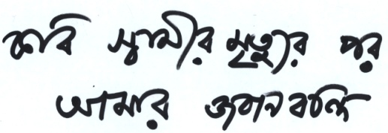

Original title: Kobi Swamir Mrityur Por Amar Jobanbondi
English title: Statement After My Poet Husband’s Death
A film by Tasmiah Afrin Mou

TAGLINE
A simple Bangladeshi middle class Muslim woman who doesn’t feel any sorrow after her husband’s death whom she loved very much.

SYNOPSIS
The film Statement After My Poet Husband’s Death portrays the emotions of a recently widowed woman who’s having a feeling of deliverance after the death of her poet husband.

LONG SYNOPSIS
This film is about a psychological journey of a woman named Rubi; once she loved her husband devotedly but the feeling is long gone. Sitting beside her husband’s dead body, she doesn’t feel any grief or any other emotion whatsoever. She remembers her life with this man, and discovers that her once beloved husband died to her long before his actual demise. Rubi is not a self declared feminist but her surroundings and her life-struggle made her a strong bold woman.

OFFICIAL SELECTION
- 34th Festival tous courts, France, 2016
- 14th International Short and Independent Film Festival, Bangladesh, 2016.
- ISFF ZUBROFFKA International Short Film Festival, Poland, 2016
- 15th Third Eye Asian Film Festival, India, 2016
AWARDS
- Tareq Shahariar Best Short Film Award, 14th International Short and Independent Film Festival, Bangladesh, 2016.
- Special Jury Mention Award, 15th Third Eye Asian Film Festival Mumbai, India, 2016.

FESTIVAL LINK
http://festivaltouscourts.com/FTC2016/competition-internationale-decouvrez-selection/ (34th Festival tous courts, France, 2016)
http://isiff-bd.org/ (14th International Short and Independent Film Festival, Bangladesh, 2016.)
http://www.zubroffka.pl/en/ (ISFF ZUBROFFKA International Short Film Festival, Poland, 2016.)
http://www.affmumbai.org/curthieye/filmsections.php (15th Third Eye Asian Film Festival, India, 2016)

DIRECTOR’S STATEMENT
Though love relation is beleived to bring happiness in a woman’s life, often it causes pain and abasement. Still, a simple woman goes far and accepts a lot of disgrace for his love. But, after a certain period, the feeling of love dies from continuous abjection. The breathing person she loved becomes dead to her. Even the actual death of that person comes as relief. Despite being brought up in a country that is historically male dominating, an ordinary Bangladeshi woman often tend to take some difficult but vital decisions which come from the lesson of self esteem her culture taughts her. The family structure in bangladesh facilitates a mental shelter for the ordinary woman taking any important life decision long after she is matured or married. An ordinary woman could become the symbol of self esteem, not through practising any recognized feminist lifestyle, rather living her ordinary stolid life.

DIRECTOR’S NOTES ON THE FILM
I was brought up in Bangladeshi Middle Class society where a educated girl quickly comes into the attention of the so-called progressive part of the society for taking part in creative activities. At first, her works are appreciated, but soon, the the so-called progressive males starts to proclaim love towards her. Interestingly, that very males lose interest to their wives soon after their marriages. It is thought that the woman will love his husband forever and no matter what, she will try to protect her marriage. But a creative person is also a self esteemed one! For this, the main character of this short film, Ruby, loses the feeling of love she once possessed towards her husband from continuous abjection from the same; and she decide to be separated from him. She wants to live; for herself. For that reason, Ruby doesn’t feel grief or any other emotion following her husband’s death. He was dead to her long before his actual death. Who knows, we might see him dead on screen, only because he is dead to Ruby!

DIRECTOR’S BIO/FILMOGRAPHY
Tasmiah Afrin Mou is a young filmmaker from Bangladesh. Statement after My Poet Husband’s Death is her debut short film. Before this, she made a handful of Documentary films. One of her Documentary films Tokai-2012 received the Award for Best Short Documentary at Guangzhou International Documentary Film Festival, China in 2014. She was born 9th November 1983 in Dhaka, Bangladesh. She completed her Honors and Masters’ degree majoring in Political Science from University of Dhaka. She is also known as a writer. Her short story book Baksha Bondi was published in 2015.

- Statement after My Poet Husband’s Death (15 min, Bangladesh 2016), Director’s Debut Short Film.

Documentary Films:
- I am the History (18 min, Bangladesh, 2014)

- English title: The Heroes (18 min, Bangladesh, 2014)
- English title: Desertion (19 min, Bangladesh, 2012)
- English title: Tokai 2012 (22 min, Bangladesh, 2012)
youtube links:
http://www.youtube.com/watch?v=0anCwvPznxg&feature=share
http://www.youtube.com/watch?v=n3x3gIl3d48
- Seed Tactics (23 min, Bangladesh, 2010)
- A Tale of Transformation (38 min 42 sec, Bangladesh, 2007), Debut Documentary Film. Merriment hardship
MAJOR CAST & CREW
CAST
Dilruba Hossain Doyel as RUBI
Ali Ahsan as RUBI’S POET HUSBAND
Maria as CHILD RUBI
Raita as RUBI’S DAUGHTER
Irin Parvin as RUBI’S MOTHER
Voice Acting: JYOTIKA JYOTI

CREW
Story, Screenplay and Direction: Tasmiah Afrin Mou
Cinematography: Imranul Islam
Editing, Sound Designing & grading: Sujan Mahmud
Executive Producer: Mostaq Ahmed Titu
Music: S K Shaan
Art Director: Awlaad Rinto
Assistant Director: Mizanur Rahman Rubel, Anjan Shejan
Costume: Murshida Reasat
Producer: Rubaiyat Hossain

TECHNICAL INFO
Genre: Drama
Running Time: 15 Min
Original Language: Bengali
Available subtitle: English
Screening Format: HD
Sound: Stereo (AAC)
Screening Ratio: 16:9
Country of Origin/Production: BANGLADESH
Production Year: 2016
Production Company: KHONA TALKIES

POSTER OF THE FILM
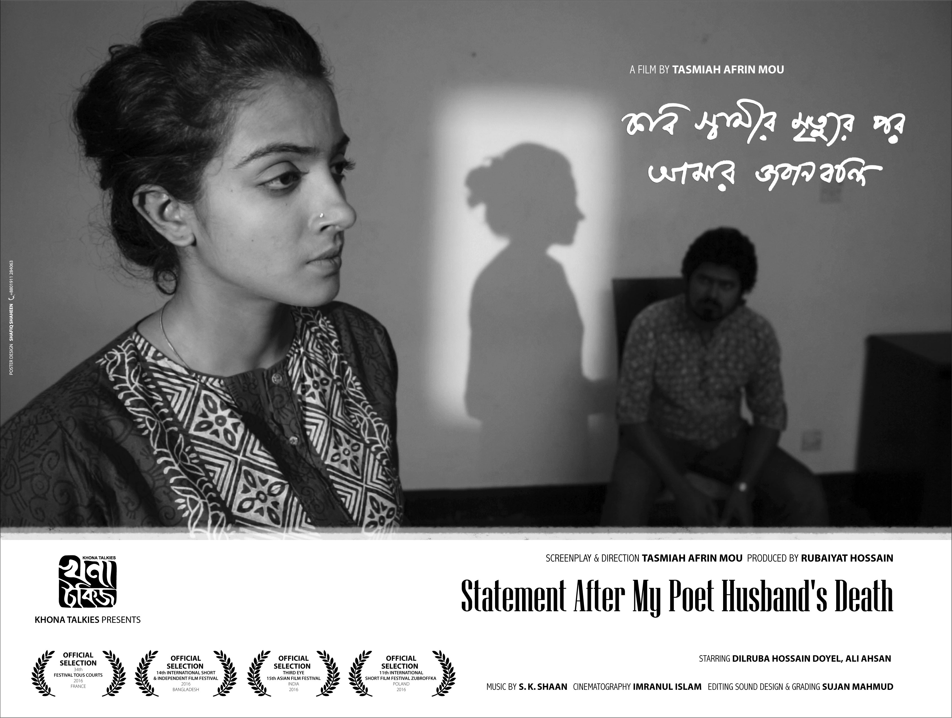

CONTACT
Ashik Mostafa
Khona Talkies, Level 14, UTC Tower, Panthapath, Dhaka-1215, Bangladesh
Tel: +88-02-8154124, +88-02-8159518, Fax +88-02-8159787
Mob: +880 1777655225
Email: ashique.mostafa@yahoo.com
Tasmiah Afrin Mou
Current Address: 57 Sohrawardy Avenue, Baridhara, Dhaka-1212, Bangladesh.
Mob: +880 1918377977, +880 1841710036
Email: moutomou@yahoo.com

